X Linked Genetics in the Calico Cat
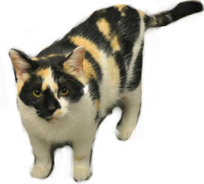
The coloration of calico cats is also the result of the inactivation of one of a female cat's sex chromosomes. In females, two X chromosomes are present in all cells but only one is active, the inactive one is called a BARR BODY. This is why the coat color is random, even among cloned calico cats that have identical genomes.
Read about Rainbow and CC to learn more about cloning calico cats.
Calico is a coat color found in cats, which is caused by a SEX-LINKED, CODOMINANT allele.

B = Black
R = oRange
BR = calico
The following genotypes are possible;
Female cats can be black X^{B}X^{B}, orange X^{R}X^{R}, or calico X^{B}X^{R}
Male cats can be black X^{B}Y or orange X^{R}Y
Show each of the crosses below and include the phenotypic ratios of the offspring.
1. A black male crossed with an orange female

2. An orange male crossed with a calico female

3. A black male crossed with a black female

4. An orange male crossed with an orange female

5. A black male crossed with a calico female

**If you are a cat breeder, what type of parents should you choose to have the MOST number of calico kittens?

