The ribosome made out of rRNA and protein binds to the mRNA at the start codon, which is ________. The exposed start codon on the mRNA attracts a tRNA with a complementary anticodon UAC and corresponding amino acid, methionine.  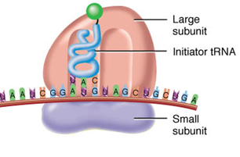 | Another tRNA with an amino acid is attracted to the next codon on the mRNA, bringing it very close to the other tRNA molecule.  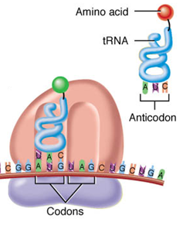
The ribosome forms a peptide bond between the two amino acids, releasing them from the tRNAs.  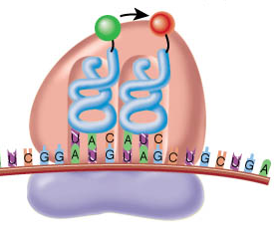 | The process continues with the ribosome translating the mRNA strand and with tRNAs with complimentary anticodons providing amino acids.  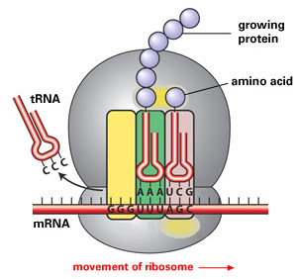
Translation ends when the ribosome reaches a stop codon on the mRNA. The completed polypeptide chain is released.
