Name___________________________ Period_______ Group #________

Photosynthesis Investigation
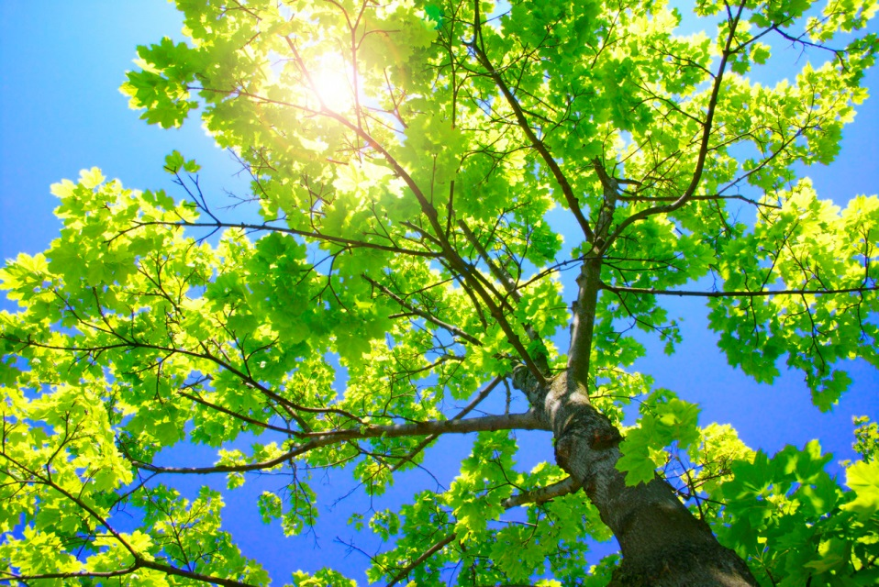

Procedure:
- Place 75 ml of bromothymol blue in a beaker.
- Observe the color of the solution.
- Introduce carbon dioxide into the solution. Use a straw to slowly blow carbon dioxide from your lungs into the solution until it just turns yellow.
- Pour the solution into three screw cap test tubes, dividing it evenly.
- Get one 6 cm piece of Elodea, place it in one of the tubes, and cap it.
- Get another 6 cm piece of Elodea, place it in a second tube completely covered with foil (to prevent light from reaching the solution & Elodea), and cap it. In both of these test tubes, be sure the plant is completely submerged in the solution.
- Cap the test tube that has no plant in it.
- Place the test tubes into a beaker of water and put the beaker next to the window.
- Allow the plants to sit undisturbed for overnight.
- Compare the colors of the solutions by removing the plants and holding the tubes in front of a white background. Record the final colors of all three tubes.
- After all measurements have been completed, rinse out your glassware.

Data:
Observation of Test Tubes
Test Tube 1:  BTB Solution & Elodea  No Foil |  | Test Tube 2:  BTB Solution & Elodea  Foil |  | Test Tube 3:  BTB Solution  No Foil
START | After 24 Hours | START | After 24 Hours | START | After 24 Hours
Data Analysis
- Which test tube(s) showed a color change in this investigation?

- What does a color change indicate in this investigation?

Questions
- What is the independent variable in this investigation?

- What is the dependent variable in this investigation?

- What are some controlled variables in this investigation?

- What color is the water in all three test tubes at the start of the activity?

- What does this color tell us?

