Formative Assessment Analysis

Ashlie Kinnaman

Four Chosen Assessments

- Three – Two – One: In this formative assessment, students respond to three reflective prompts; providing six responses (three of the first, two of the second, and one final refection) that describe what they learned from the lesson or unit of instruction. Student responses provide the teacher which information about what students perceive to be the key concepts of a lesson. They can give teachers an insight to how well the lesson’s objectives were met. This assessment demands little time, is easy to use and is best used when students are learning something new. For this reason, I chose this assessment to evaluate the following benchmark, SC.912.L.16.9 Explain how and why the genetic code is universal and is common to almost all organisms. Emphasis was put on DNA structure and the scientists who helped discover DNA as the carrier of genetic information. I gave the assessment after the students completed the lab, Have Your DNA and Eat It Too, which is why I chose one that could be completed in few minutes. A powerpoint slide presented the three prompts and students were provided a post-it note to answer them. The specific questions of the assessment are as follows:
  - Write three things you know about DNA structure.
  - Name two scientist who helped discover DNA is the genetic material in organisms.
  - Describe one concept with which you are struggling
This assessment was given to approximately 43 ninth graders. In order to accommodate visual as well as auditory learners, I read the questions aloud in addition to posted them for the class to read.

- First Word – Last Word: Students construct statements about a concept before and after instruction that begins with a designated letter of the alphabet. The designated letters make up a particular topic word. This formative assessment is used to activate student thinking about a concept before they begin learning about it. It requires students to think about what they already know. Students reflect on their statements at the end of instruction and modify or create new statements that fit into their new understanding of the concept. In addition, the assessment gives teachers an opportunity to uncover misconceptions at the beginning of a unit of instruction and see how students initial ideas change and develop by the time the unit ends. I chose this formative assessment to evaluate the following benchmark: SC.912.L.18.7 Identify the reactants, products, and basic functions of photosynthesis. Students were told to complete the First Word portion using the word, photosynthesis. I selected this formative assessment since we were switching topics from evolution to photosynthesis and plant structure. It would give me an idea of students’ present knowledge about the topic. The assessment was given to 18 ninth graders. To accommodate different learning styles, the only requirements for the assessment were that each line had to start with the designated letter and describe some aspect of photosynthesis. Students were assured that words, phrases, or sentences would be accepted and that finishing the activity was the goal. Instead it was presented as an activity for them and me to check their understanding. This accommodated students who were not as comfortable writing as well as those who feel pressured to finish activities in a limited amount of time.

- P-E-O Probes: This formative assessment presents a situation to students and asks them to predict an outcome and to explain the reasoning that supports their prediction. After completing the assessment, students are given a chance to observe the actual results and reflect on their explanations. This assessment provides students to develop skills within inquiry, allowing them to revise their explanations when new evidence is available. It also provides the teacher with information on students’ preconceptions about the concept or topic. During the unit on photosynthesis, students completed an experiment to investigate the reactants of photosynthesis (SC.912.L.18.7 Identify the reactants, products, and basic functions of photosynthesis). After setting up the experiment, I had students complete this assessment so they could predict their results, an important part of the investigative process. We then discussed their predictions as a class. Students were able to see the actual results the next day once the experiment had sat overnight. The specific prompt given to them was as follows:
  - In your experiment, you have three test tubes with bromothymol blue, two of them have Elodea, and one of them is covered with foil. Write a short paragraph predicting what you will observe in your test tubes tomorrow and explaining why you think that will happen.
This assessment was given to 18 ninth graders. Because students were expected to write their response in paragraph form, this assessment accommodated students who felt more comfortable writing than dealing with the experiment, or data.

- Annotated Student Drawings: This formative assessment asks students to create labeled illustrations that visually represent their thinking about a concept. It challenges students to make sense of their ideas since they must explain the concept with the minimal use of words. Teachers can give this assessment after instruction to further solidify understanding and to see if clarifying of certain ideas is still needed. This assessment was used to evaluate the following benchmark: SC.912.L.14.36 Describe the factors affecting blood flow through the cardiovascular system. It was given after learning how blood moves through the human vascular system. Students were asked the following:
  - Draw and label a picture that would help someone understand what happens to a red blood cell as it goes through the circulatory system. Characteristics of arteries, veins, capillaries and other components of the blood should be included. Arrows showing the flow of blood should also be included. Use the least amount of words possible.
This assessment was given to approximately 43 ninth graders. It accommodated students who are strong visual learners and communicators because many of the assessments given have been text only.

Rubric for P-E-O Probes
 | KI Level | Response Description | Example Response
Complex | Students understand how more than two science concepts interact in a given context. | Elaborate two or more scientifically valid links among ideas relevant to a given context. | I predict that tube with the Elodea covered with foil will have yellow colored solution tomorrow since no sunlight will reach the plant. Photosynthesis cannot occur without the energy from the sun and will not be able to convert carbon dioxide into glucose. The carbon dioxide will stay dissolved in the water as carbonic acid and the BTB indicator will still be yellow.  The tube with just the solution of BTB will also be yellow tomorrow since the tubes are closed so carbon dioxide dissipate into the air and there is no plant to take up carbon dioxide for photosynthesis. The concentration of carbonic acid in solution should be unchanged and as a result, the BTB indicator should still be yellow.  The tube with Elodea and no foil will have a blue solution tomorrow because sunlight will reach the plant and provide the energy for photosynthesis. The plant will use the carbon dioxide dissolved in the water to create glucose thus decreasing the concentration of carbonic acid in the water.
Basic | Students understand how two scientific concepts interact in a given context. | Elaborate a scientifically valid link between two ideas relevant to a given context. | I predict the BTB solution in the tube with Elodea covered in foil will be yellow tomorrow because sunlight cannot reach the plant and photosynthesis cannot occur. The plant will not use carbon dioxide from the solution.  The tube with just the solution of BTB will not have a color change because there is no plant to take up carbon dioxide for photosynthesis and the tube is closed so as to not allow any carbon dioxide to escape.  The BTB solution in the tube with Elodea and no foil will change to blue because sunlight will reach the plant and photosynthesis will occur. The Elodea plant will use carbon dioxide from the solution.
Partial | Students recognize potential connections between concepts but cannot elaborate the nature of the connections specific to a given context. | Have relevant ideas but do not fully elaborate links between them in a given context. | I predict the BTB solution in the tube with Elodea covered in foil will be yellow tomorrow because the plant cannot do photosynthesis OR the plant will not use carbon dioxide.  The tube with just the BTB solution will not change color because there is no plant to do photosynthesis OR that the tube is closed so carbon dioxide will not escape.  The BTB solution in the tube with Elodea and no foil will change to blue because the plant will be able to do photosynthesis OR the plant will use carbon dioxide.
Isolated | Students have relevant ideas but do not connect them in a given context. | Have relevant ideas but fail to recognize links between them.  Make links between relevant and irrelevant ideas. | I predict the BTB solution in the tube with Elodea covered in foil will change to blue because the plant will produce some oxygen from the process of photosynthesis.  The tube with just BTB solution will remain the same color because it is capped so carbonic acid cannot escape and there is no plant to produce oxygen from photosynthesis.  The BTB solution in the tube with Elodea and no foil will become bluer than the one with foil because sunlight will reach the plant causing it to produce more oxygen and use carbon dioxide.
Irrelevant | Students have irrelevant ideas in a given context. | Have incorrect/irrelevant ideas. | Color changes based upon chlorophyll, due to the escape of carbon dioxide, or due to some other chemical that may be present in the test tube.  OR  Explanations involve reasoning that does not include carbon dioxide, sunlight, or photosynthesis.  OR  Explanations include erroneous information that suggests students are confused about the reactants and products of photosynthesis and the purpose of BTB indicator.  OR  No explanation is given for predicted observations.

Analysis of Student Work

Number of Students for Each Type of Response on Rubric
Complex | Basic | Partial | Isolated | Irrelevant | Total Students
0 | 4 | 4 | 6 | 4 | 18

The table above gives the frequency of each type of response described within the rubric. Out of 18 students, none of them gave a complex response, which would present knowledge of two or more links between scientific concepts. In order to achieve a complex response, students would have to demonstrate the link between bromothymol blue indicator and the concentration of carbonic acid, the link between the amount of carbonic acid dissolved in solution and the plant’s need for carbon dioxide to complete photosynthesis, and the link between sunlight and photosynthesis. These connections had to be present for each test tube they described, which was definitive quality of grading the students’ work. Some students touched upon all three connections while describing one test tube, but only described one or two connections when describing the other test tubes. The following sample of student work gives an example of incomplete connections for all three test tubes.

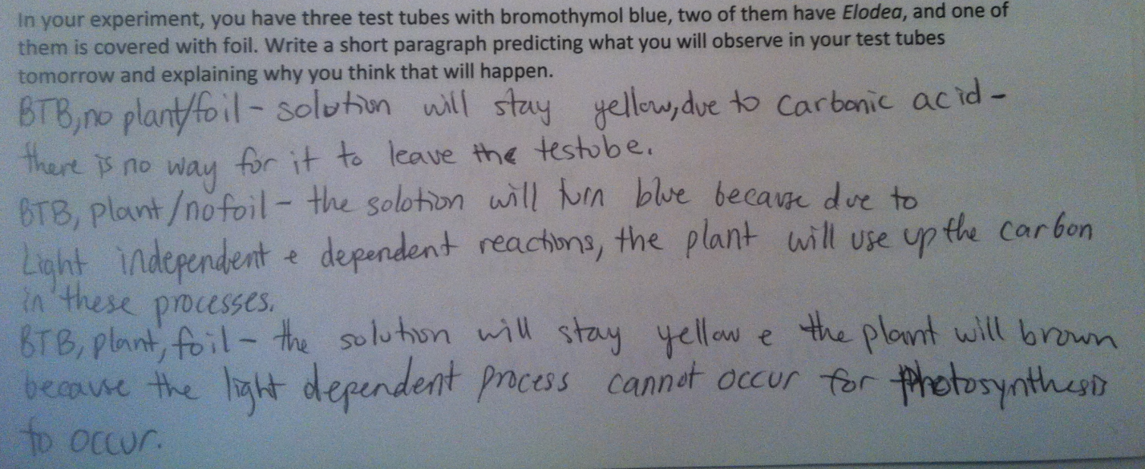

When predicting the outcome for the test tube with just BTB indicator, she states the expected color change will be due to carbonic acid since there is no way for it leave the test tube hinting that she understands the carbonic acid would otherwise be used as a source of carbon dioxide for the plant to complete photosynthesis or dissipate into the air without proper covering of the test tube. However, it is difficult to fully know what the student means without the proper explanation a complex response requires. For this reason, the student gave a basic answer. She references photosynthesis and the need for carbon dioxide, but fails to mention the concentration of carbonic acid or the importance of sunlight in her explanations for the other two test tubes. In addition to this student, three others also gave basic responses. Below is another sample of a basic response.

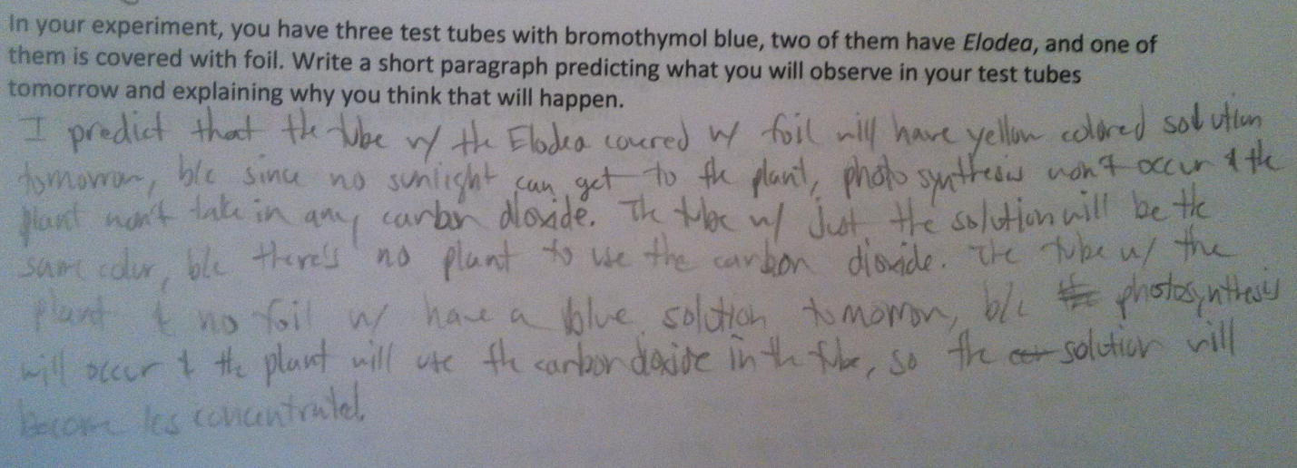

Four students within the class gave partial responses to the formative assessment. These responses give valid statements, but do not fully elaborate on the reasons why a color change does or does not happen. They may only state that a color change happens because the plant can do photosynthesis when referencing the test tube with a plant and no foil; however, this explanation lacks understanding of how the BTB indicator works, why the plant can do photosynthesis, and the importance of sunlight. All four of the partial responses had this common. All of them referenced the plant’s ability to do photosynthesis being a reason for the color change, but they did not elaborate or mention other connections. Below is a student sample of a basic response.

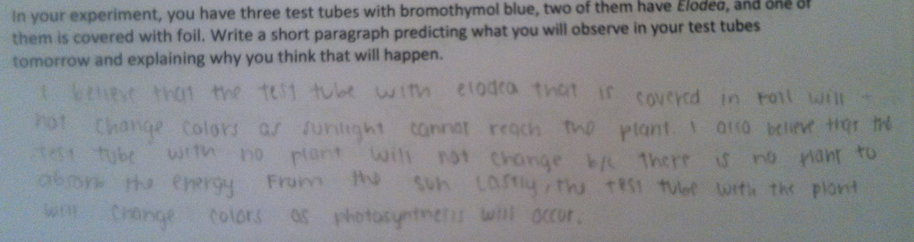

Six students wrote isolated responses. This is the mode for the student response data. Each student explained that oxygen, a product of photosynthesis, would be responsible for the color change. A plant releasing oxygen due to photosynthesis is a valid statement; however, the connection between oxygen and the color change is incorrect. Below is a student sample of an isolated response.
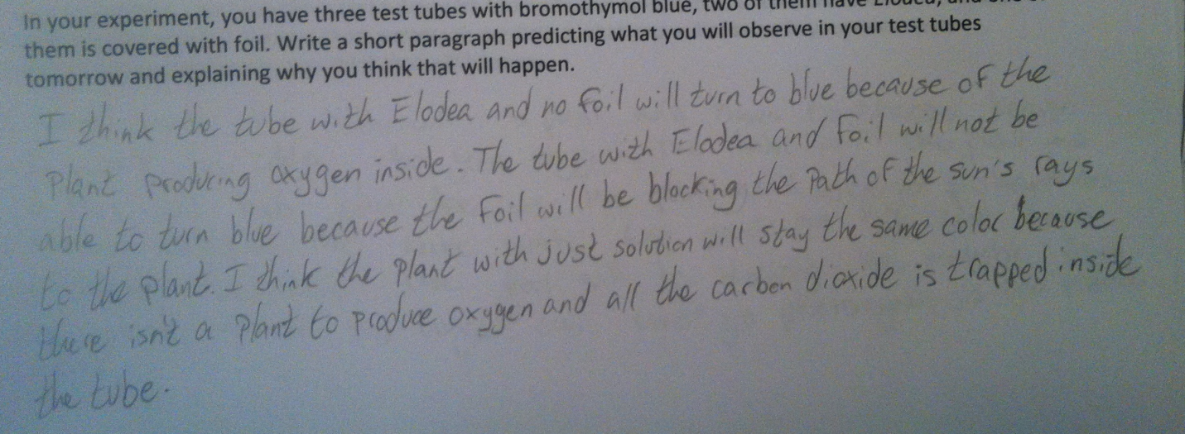

Lastly, four students gave irrelevant responses to the question. Two of them stated there would certain color changes, but gave no explanation as to why the color change will happen. The other two explained that sunlight would be the sole reason for any color change, which is incorrect. There is no reference of photosynthesis or carbon dioxide, which is why the responses were not categorized as isolated.
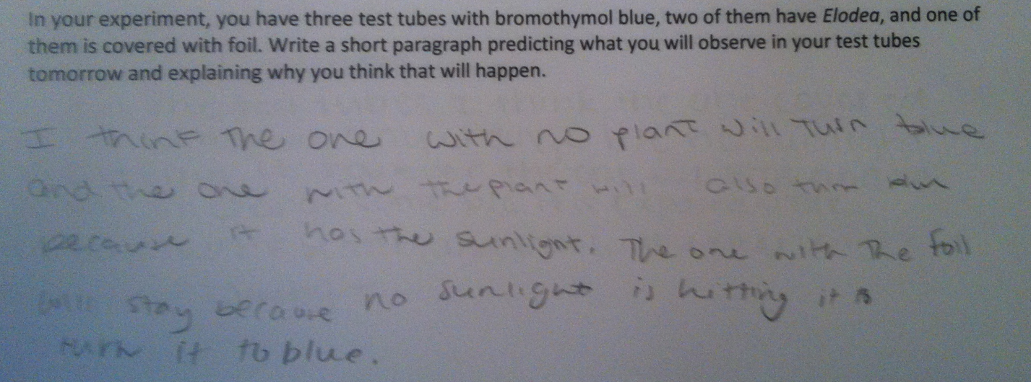

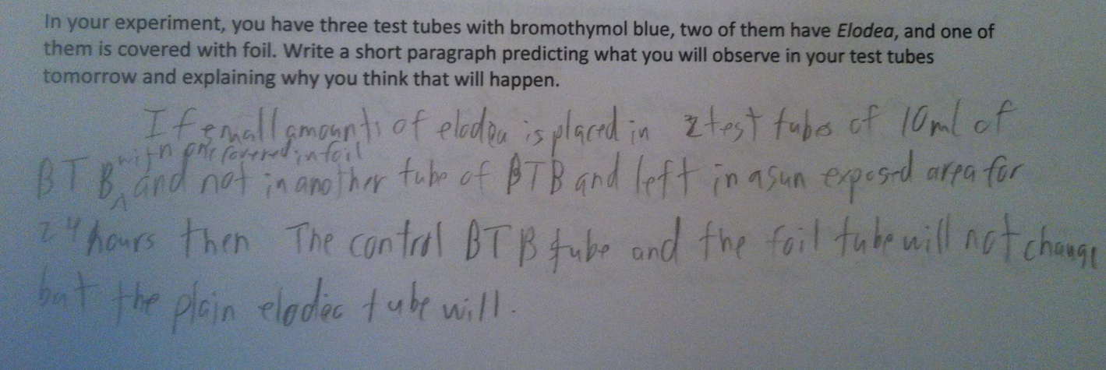

Reflection

After analyzing the students’ responses, I was very surprised to see that over half of the class, 10 out of 18 students, gave isolated or irrelevant responses as I thought that I had covered the purpose of the BTB indicator very well. Upon reading the formative assessments; however, it seems that many students, even those who wrote basic or partial answers, are still confused about the role of the BTB indicator.
In addition, I did not expect to see a third of the class describe the color change based upon the plant’s ability to produce oxygen. They explained that it is the increased amount of oxygen in solution changes it from yellow to blue rather than the decreased amount of carbon dioxide dissolved in water as carbonic acid as the reason. It is interesting to note that many of the isolated responses still understood that carbon dioxide, sunlight, and water are reactants of photosynthesis while oxygen is a product suggesting that the true gap in knowledge is more about acid-base indicators. This may be due to a limited chemistry background since all 18 students are ninth graders, who do not take a full chemistry course until 10th grade. Furthermore, it shows that, in order to complete this lab, I, as the teacher, must clearly teach the purpose of BTB indicator the connection between it’s color change and the concentration of carbonic acid.
My intent for the formative assessment was to have students give detailed explanations for their given predictions. However, it seems the majority of students think very generally about the process of photosynthesis and the lab, rather than thinking about the specific reasons or causes for something that happens. For example, many students cite just the process of photosynthesis as the cause of the color change. They did not go deeper into the subject to explain that it is the plant’s need for carbon dioxide to complete the light-independent reactions, provided the plant receives enough sunlight that causes the color change since the concentration of carbonic acid in the solution decreases. From this observation, I think the formative assessment must be reworded to facilitate deeper, more elaborate explanations.

Instructional Implications

Knowing the results of the formative assessment directly affects how the second day of the lesson should be taught. The three specific connections included in the complex response of the rubric should be touched upon through questioning during the explain of the 5E lesson. When re-teaching the lesson, more time should be spent on introducing the concept of acid-base indicators and how bromothymol blue works as an indicator of carbonic acid. Probing questions should be added to the explore portion of the lesson plan to guide student thinking and to get students thinking more specifically about the experiment and the expected outcomes. Lastly, the formative assessment must be reworded to guide students into writing the proper explanation to the question. Specific revisions are on the revised version of the two-day lesson plan.
Instructional implications for future teaching within the classroom involve adding more opportunities for students to answer open-ended questions by writing out their answers and their reasoning behind the response. In addition, strategies will be used to guide students into thinking about concepts in more detail and relating this back to the general, overall picture. These strategies can include questioning where the teacher continually probes students’ general answers, giving students experience in created more elaborate responses.

