A large transcription complex made of RNA polymerase and other proteins recognizes the start of a gene and begins to unwind the segment of DNA.

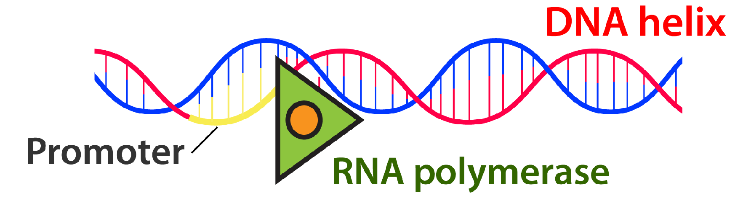
RNA polymerase uses one strand of the DNA as a template. RNA nucleotides form complementary base pairs with the DNA template. The growing RNA strand hangs freely as it is transcribed.
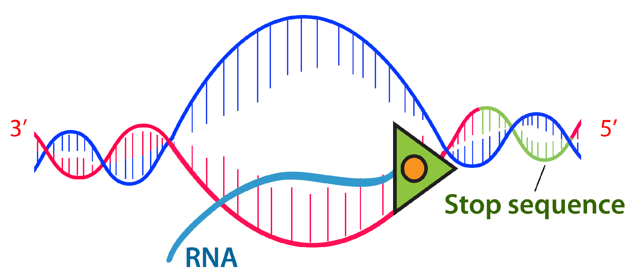

The completed RNA strand separates from the DNA template, and the transcription complex falls apart.